

Prepared by:

**Gerber Technology**

**YuniquePLM**

**Control Panel**

The Control Panel is where specific data libraries are located. Each data library is designed to populate specific pages or headers in the YuniquePLM application. Not all users should have access to the Control Panel. Access should be granted only to users who are familiar with managing specific data from an administrative level. For example the POM Library might be available to the head technical designer. To access the Control Panel click on the header name displayed on the far right of the desktop.

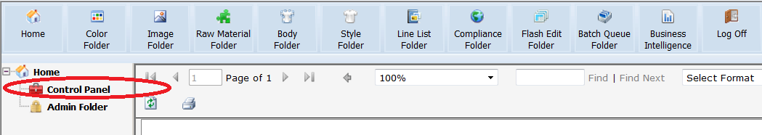

The control panel will open in a new window or tab with the main library folders listed on the left hand side of the window and the related libraries listed beneath each folder. On the right side the data specific to a selected library will be listed. Each of the libraries may have a different appearance depending on the intended purpose of the data being entered. For example, some areas may have images and others may not.

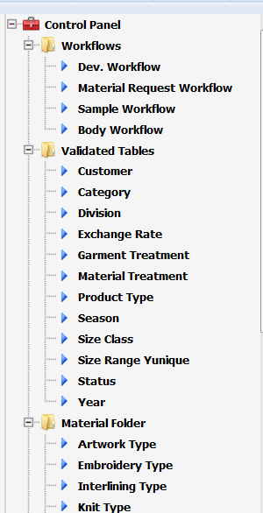

This document will elaborate on what are commonly considered to be the most critical libraries in the control panel. Once a user is familiar with how to add data to one library in the control panel, the process can be applied to all of the other libraries. Below is a list of all of the libraries in the control panel, and the area within the system that data will populate.

**Workflows**

Dev. Workflow – Controls which page “bubbles” or milestone events are included for a development or sample workflow.

Material Request Workflow - Controls which page “bubbles” or milestone events are included for a development or sample workflow.

Sample Workflow - Controls which page “bubbles” or milestone events are included for a development or sample workflow.

Body Workflow – Controls which page “bubbles” or milestone events are included for body workflow.

**Validated Tables**

Customer - Populates the style folder header field labeled “Customer”.

Category Populates the style folder header field labeled “Category”.

Division - Populates the style folder header field labeled “Division”.

Exchange Rate - Populates the Costing and RFQ nodes of a style folder.

Garment Treatment - Populates the style folder header field labeled “Garment Treatment”.

Material Treatment – Populates the Material Folder.

Product Type - Populates the Material Folder

Season - Populates various areas of the software application where Season is indicated.

Size Class - Populates the style folder header field labeled “Size Class”. And once populated on the header, the data will push forward to the Development Spec and Graded Spec pages within that folder.

Size Range - Populates the style folder header field labeled “Size Range”. And once populated on the header, the data will push forward to the Development Spec and Graded Spec pages within that folder.

Status – Populates the “Status” field on the Workflow node of a style folder, and the “Submit Status” field in the Sample Request node.

Year - Populates various areas of the software application where Year is indicated.

**Material Folder**

Artwork – Populates the Material Folder

Embroidery Type – Populates the Material Folder.

Interlining Type - Populates the Material Folder.

Knit Type – Populates the Material Folder.

Label Type – Populates the Material Folder.

Lining Type – Populates the Material Folder.

Packaging Type – Populates the Material Folder.

Stitch Type – Populates the Material Folder.

Thread Type – Populates the Material Folder.

Trimming Type – Populates the Material Folder.

Woven Type – Populates the Material Folder.

Yarn Type – Populates the Material Folder.

Zipper Type – Populates the Material Folder.

**Care**

Bleach – Populates the Care page of a style folder.

Care Template – Populates the Care page of a style folder.

Cycle – Populates the Care page of a style folder.

Dry Cleaning – Populates the Care page of a style folder.

Drying – Populates the Care page of a style folder.

Ironing – Populates the Care page of a style folder.

Washing – Populates the Care page of a style folder.

**Details**

Design Template – Populates the Design Details page of a style folder.

Process Details – Populates the Process Details page of a style folder.

**Measurements**

Measurements – Stores the POM, grade rule, tolerance, and how to measure information that populates the measurement page of a style folder.

Measurement Size Range – This is where the size ranges that are used in the Measurement library are established.

Measurement Size Class - This is where the size class information that is used in the Measurement library is established.

**Other**

This is an extra library folder that can be used for customer specific configuration storage. If any data configuration has taken place, and libraries are built that do not correspond to the existing filing structure, this folder is available.

If additional folders are required, highlight the Control Panel node at the top of the folder list on the left side of the explorer.

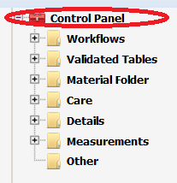

A list of existing folders will be presented on the right side of the screen. At the bottom indicate the number of new folders needed and the click the **Add** button.

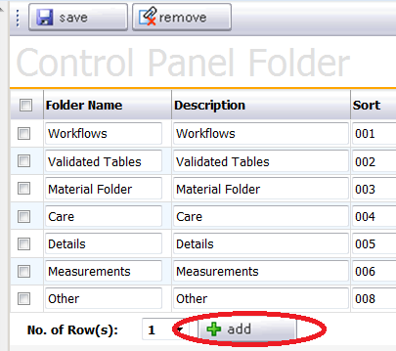

Give the new folder(s) a name and then click the **Save** button in the upper right.

To organize the data libraries into the appropriate control panel folders, highlight the folder name on the left side of the explorer. On the right side of the screen two columns will be presented. Select the appropriate libraries for the folder from the left column and move them to the right column using the green control arrows in the center. Once all libraries have been selected for the folder click **Save** in the upper right.

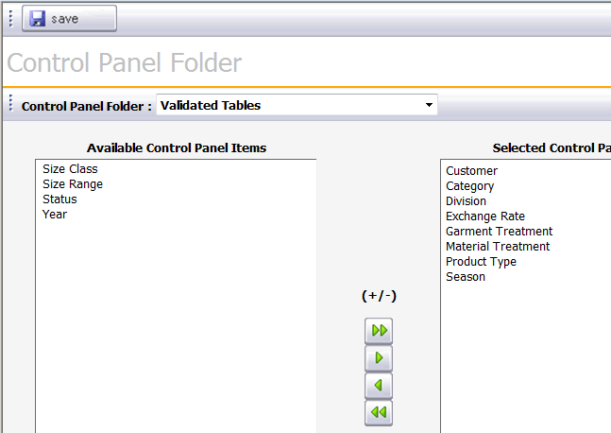

**Measurements**

To prepare for the Measurements set up in YuniquePLM identify the following in your company:

Divisions (if your company doesn’t have divisions, simply use the company name)

Product types

Size Classes (ex: Missy, Junior, Men, Women, Toddler, etc.)

Size Ranges (ex: XS-XXL, 0-16, 24-60 etc.)

Measurement Alternates (ex : Short, Average, Long)

Points of measure (POM) with corresponding codes, descriptions, how to measure (HTM) text and how to measure images

Grading type: Incremental or Relative

Standard of measuring: Imperial or Metric

**\*NOTE:** All of the tables needed to be set up are under the Measurements folder except Division. Division is in the Validation Tables

Division

In the left navigation, click on the Control Panel, then in the Validation Tables, click on the Division.

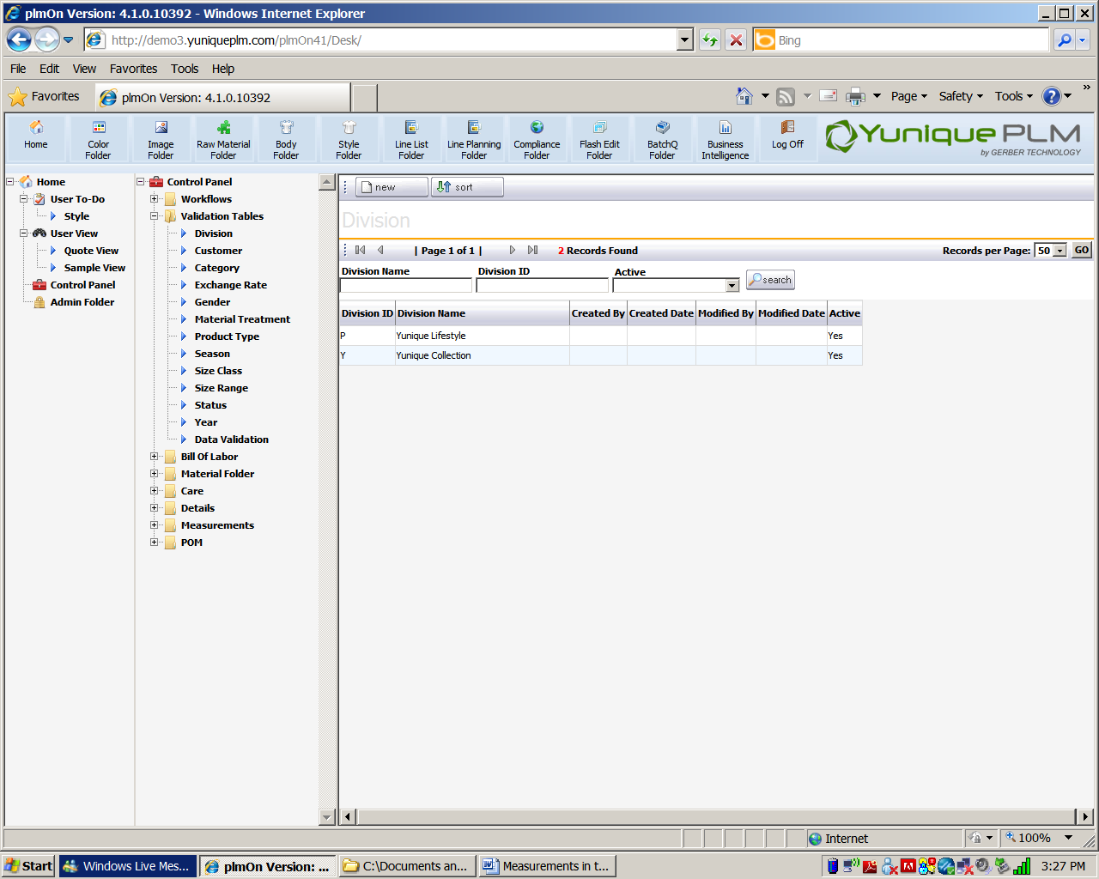

Click the **New** button.

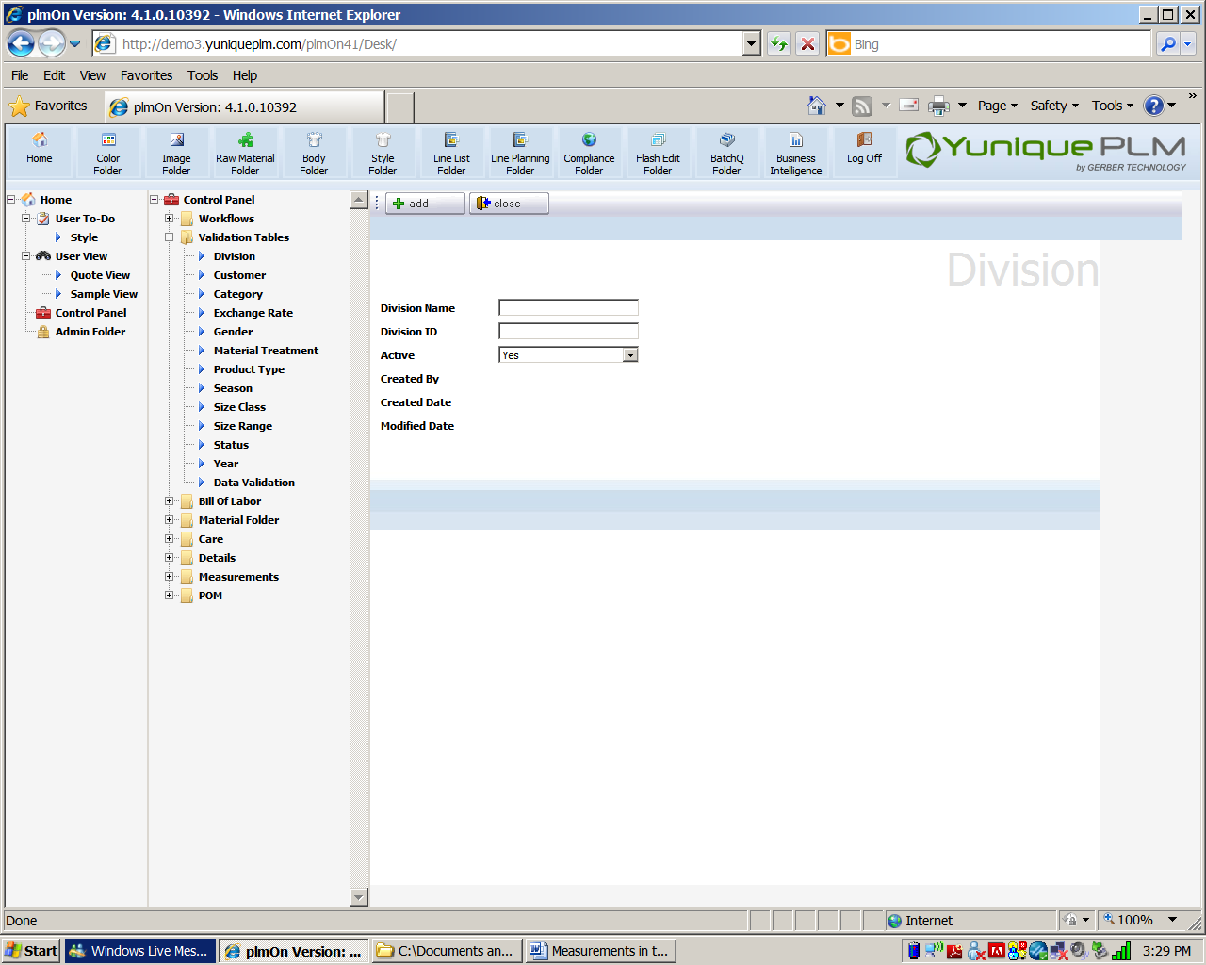

Type the division name in the Division Name field. Type the division ID in the Division ID field. For the active field, select Yes or No from the drop down list.

Click **Add** to complete the process. Click **Close** to discard changes.

Size Class

In the left navigation, click on the Control Panel🡪 Measurements🡪 Size Class.

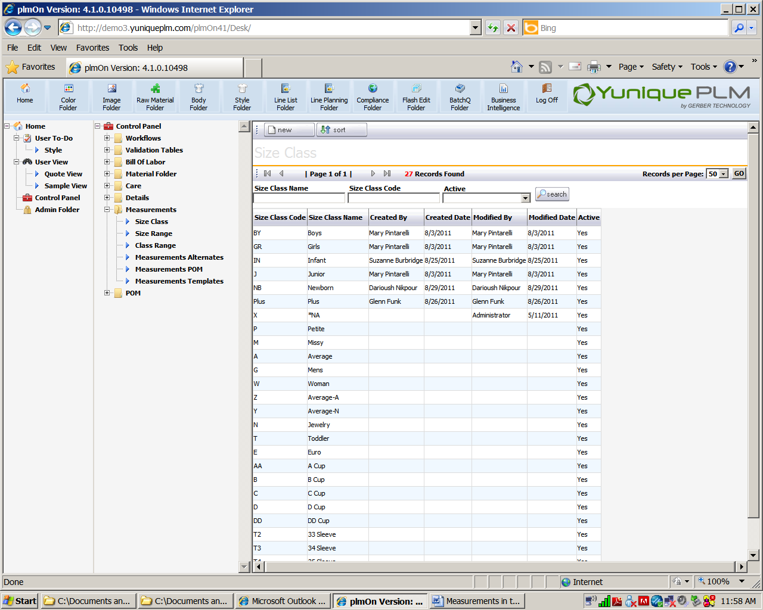

Click **New** to add a new size class. Example: Men’s, Women’s, Children, Missy, Junior

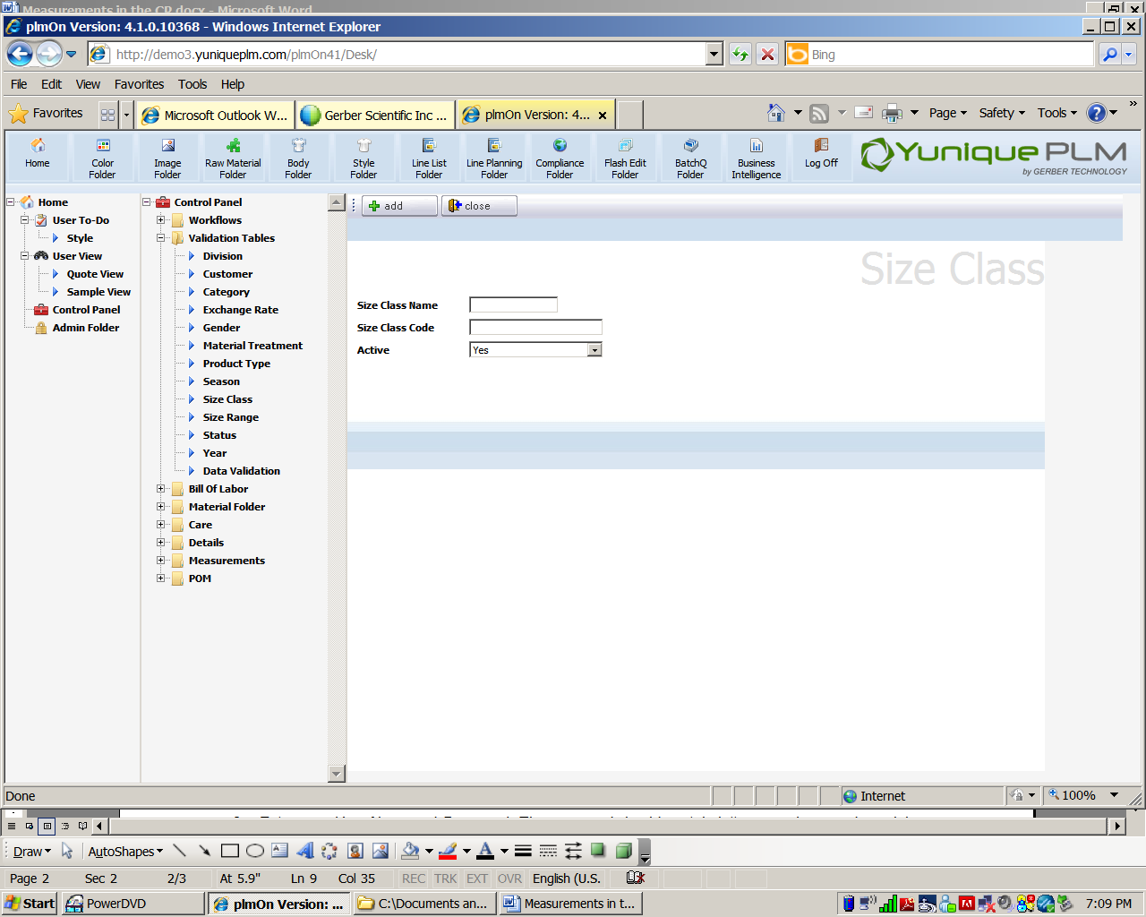

Type in a size class name, a size class code and determine whether or not it is active by selecting yes or no from the drop down list. Click **Add**, then click **Close**.

Size Range

In the left navigation, click on the Control Panel🡪 Measurements🡪 Size Range.

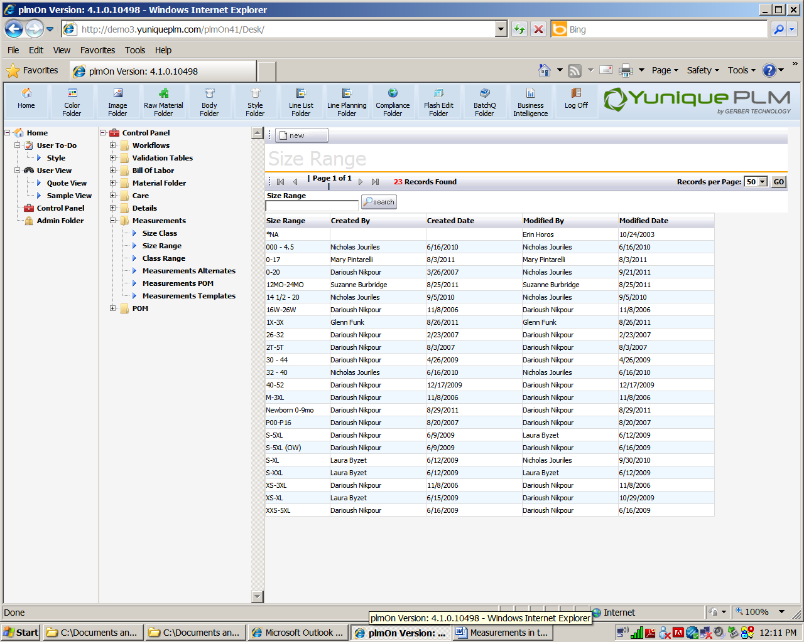

Click the **New** button to add a new size range.

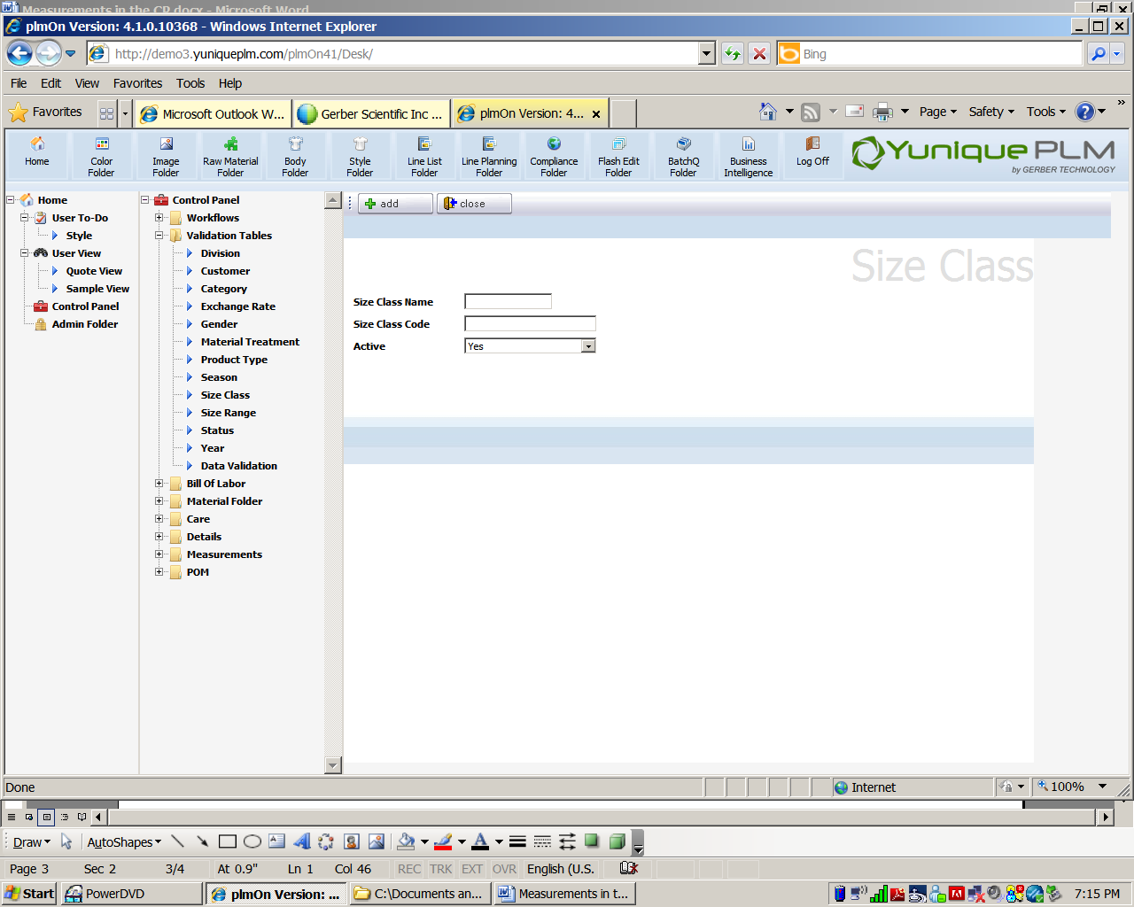

Add a Size Class Name, Size Class Code and yes or no for whether or not it is active.

Class Range

In the left navigation, click on the Control Panel🡪 Measurements🡪 Class Range

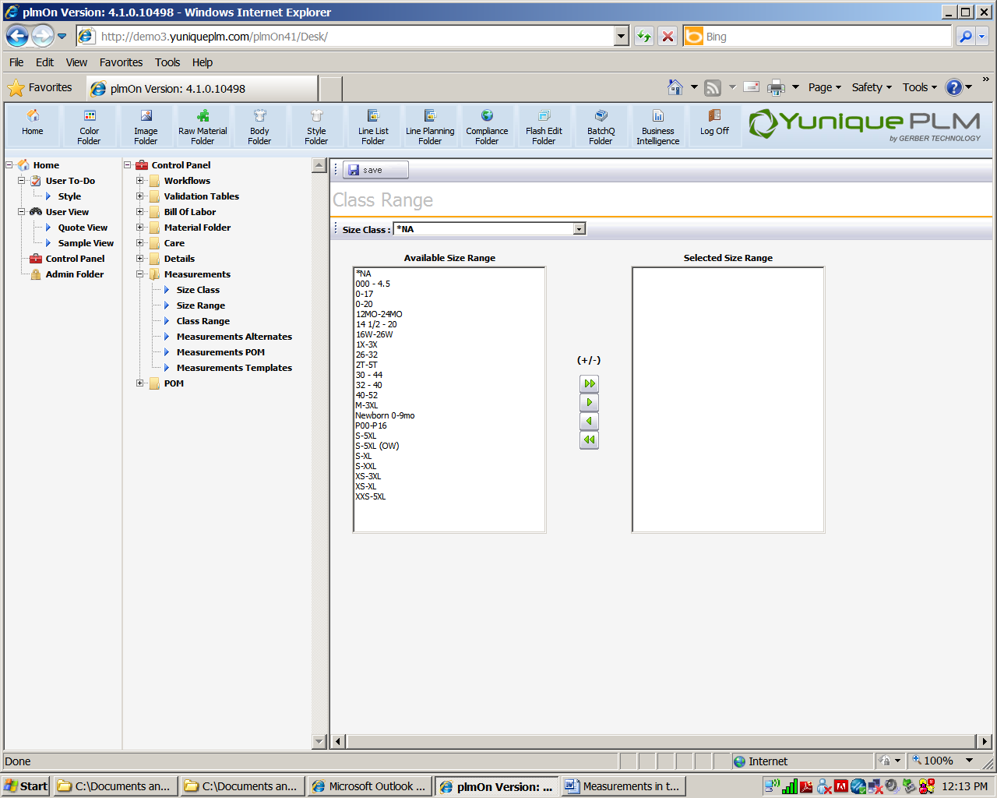

This table assigns Size Ranges to Size Classes.

Click on the Size class drop down field, select the size class desired. On the left window box will be a list of the available size ranges.

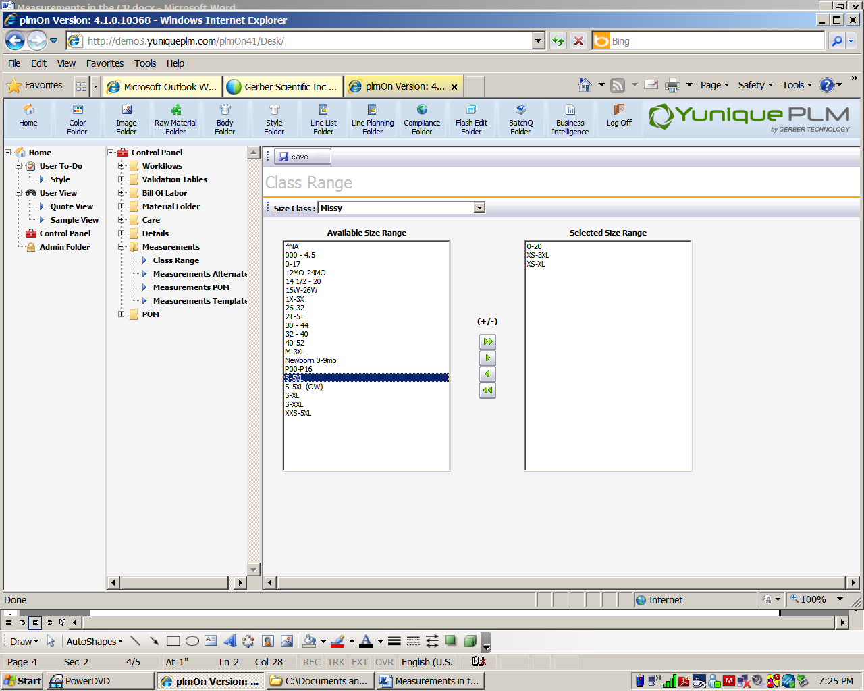

Click on the size range and then on the (+/-) icons in the center to move size ranges to and from Available Size Range and Selected Size Range boxes.

Click the **Save** button.

Measurement Alternates

The next folder to set up is the Measurements Alternates. Measurement alternates are added to specific points of measure that get the same grade rules, but different sample measurements. Example: an alternate for and inseam is short, regular and long.

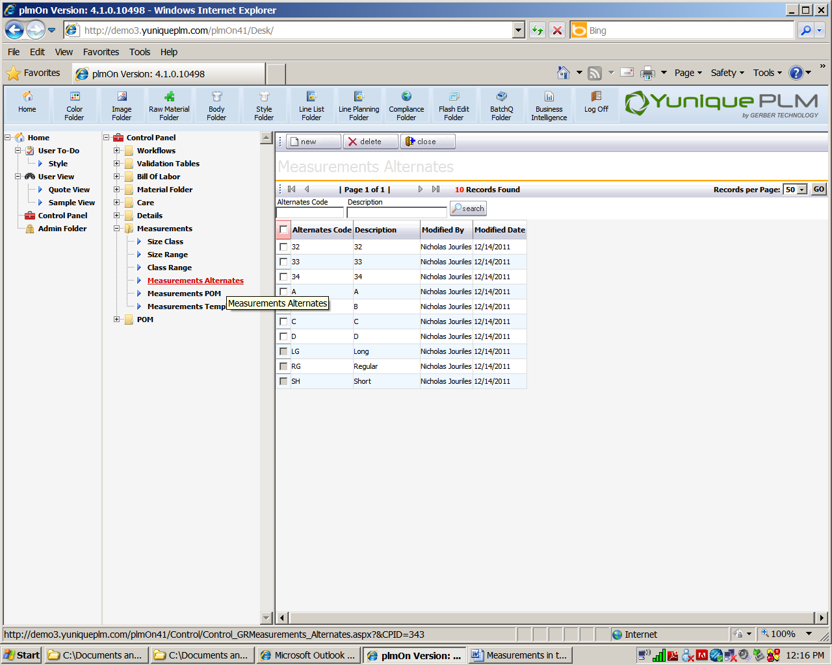

To add a new alternate, click the **New** button at the top of Measurement Alternates.

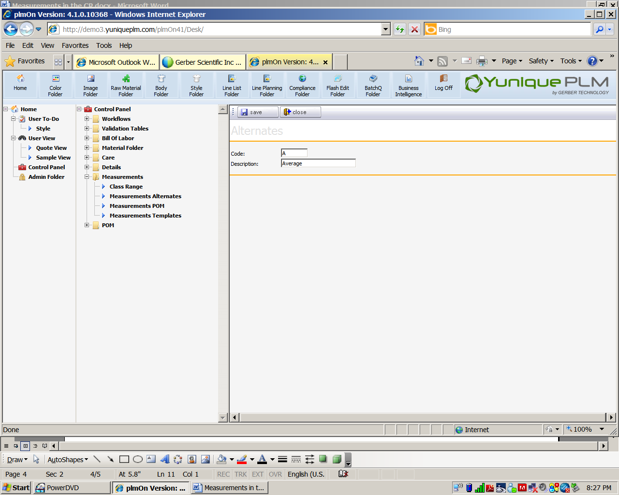

Enter a code and a description. Click the **Save** button or **Close** to discard.

To delete an alternate, click the check mark box on the left of the alternate. Click **delete**.

Measurements POM

In the left navigation, click on the Control Panel🡪 Measurements🡪 Measurements POM

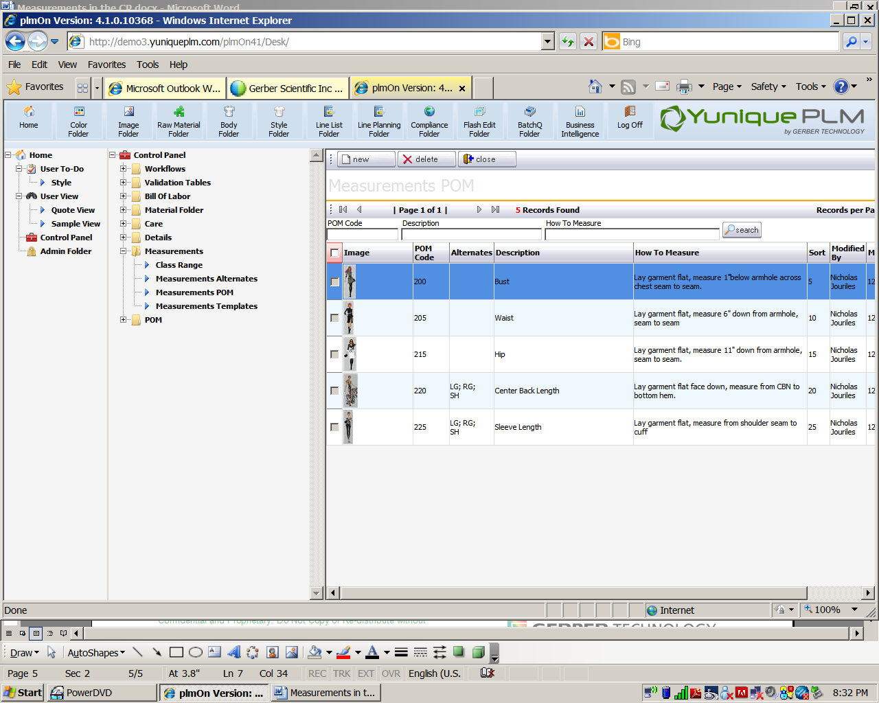

To add a new Measurement POM, click the **New** button.

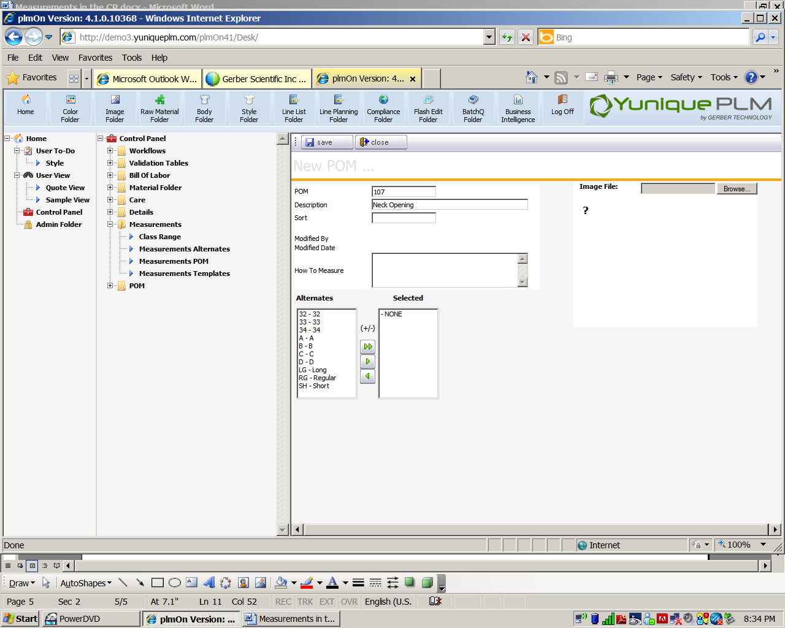

Place a POM code in the Code field. Put a POM description in the Description field.

The sort field is optional but requires a numeric value. It is needed only if the POM codes do not sort in the order that the POMs should actually be measured.

**\*NOTE:** If sort numbers are used, consider numbering by 5’s. Ex: 0001, 0005, 0010 etc with “room” in between numbers in case another POM would need to be sorted in between 2 existing POM’s.

How to measure text can be added to the How to Measure field.

Alternates can be added (or removed) in the next area.

**\*NOTE: “**None” is an alternate value that will always be a populated by default.

HTM Image

In the upper right area is place for an image. This is where the How to Measure image is attached to the POM. Click browse to locate the file and select it. (Optional)

Click the save button or click close to discard entry.

To delete a measurement, click on the measurement and select the delete button.

**\*NOTE:** POM’s cannot be deleted if they are in use in a style folder.

Measurement Templates

Measurement templates are the collection of all the Point of Measures that will be used for a specific product type that is paired with a specific size range.

In the left navigation, click on the Control Panel🡪 Measurements🡪 Measurements Template

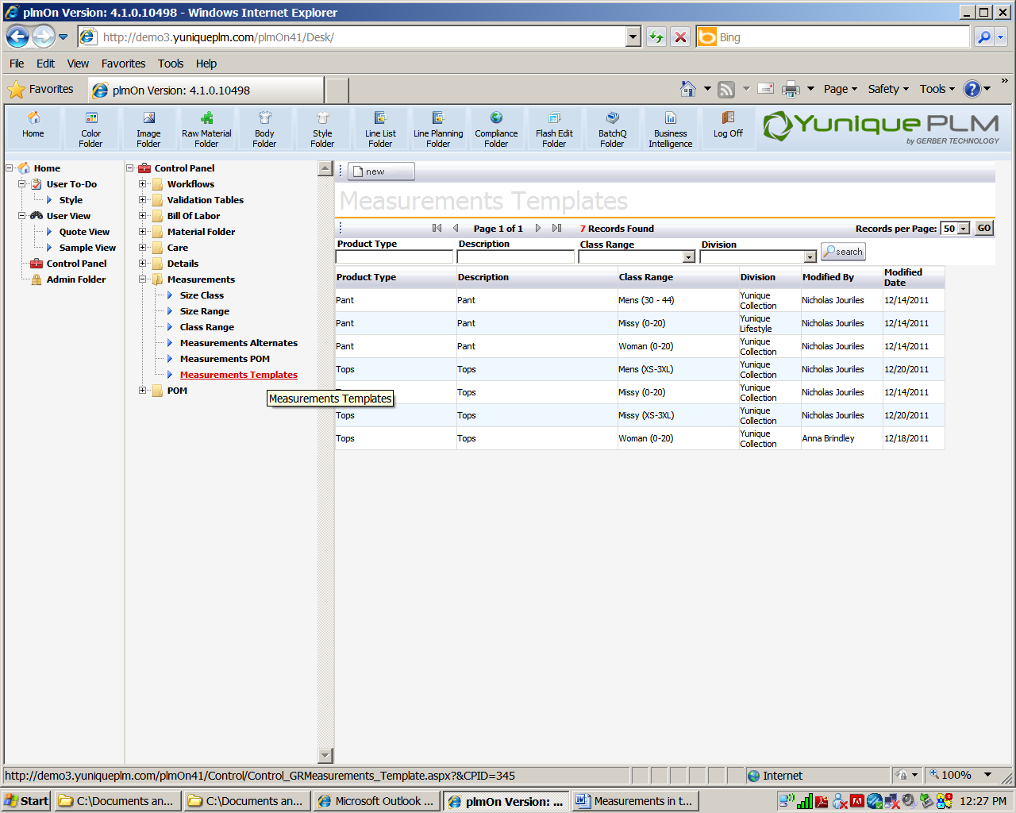

To create a new Measurement Template, click the **New** button.

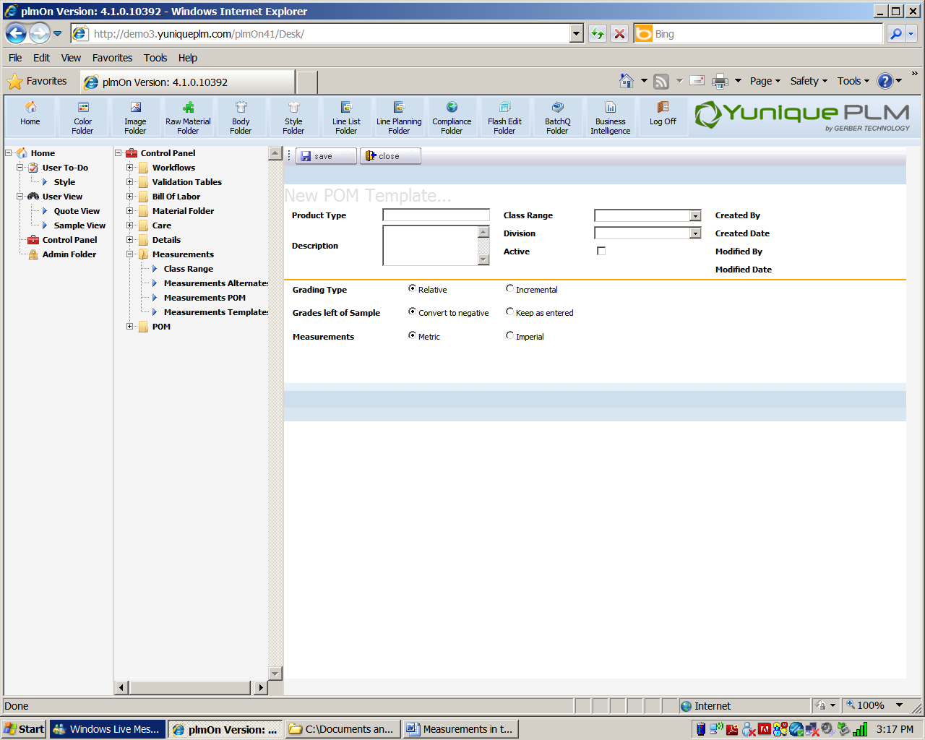

Above the gold line, enter a product type in the product type field. Enter a description in the description field. In the Class Range field, select class/size range combination from the down list. In the division field, select a division from the drop down list.

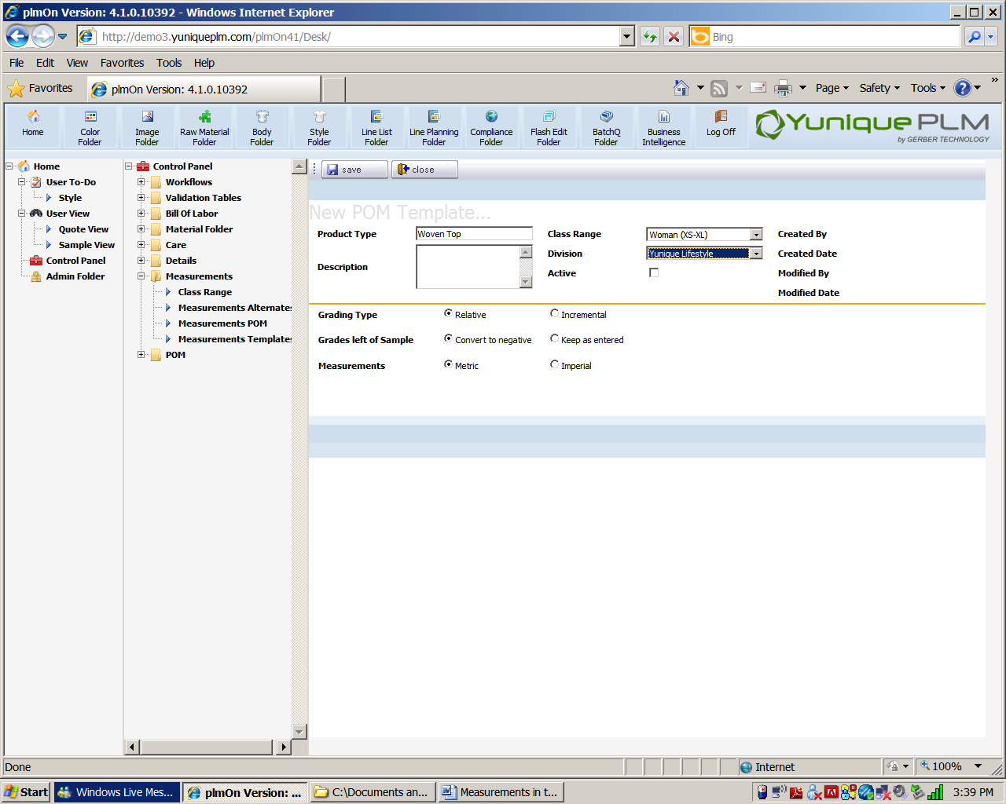

Grading Type

Below the gold line in the dialog area, select the appropriate grading type: Relative or Incremental. Relate is grading that adds a value for every size based or “relative” to the sample size. Incremental grading is grading that occurs from the size to size.

Grades left of the Sample

YuniquePLM will automatically convert all grades to the left of the sample to negative with the convert to negative radio button selected. To keep grades as entered, select the keep as entered radio button.

**\*NOTE:** Product types such as bras may have some Points of Measure that may actually get bigger or “grow” to the left of the sample. That is why there is a choice.

Measurements

Some companies use both Metric and Imperial which is why it is an option at the division level of the measurement set up.

**\*NOTE:** No matter which standard is chosen YuniquePLM automatically converts the numbers from metric to imperial or imperial to metric on the style/page level.

Click the **Save** button.

Click the **Close** button to discard changes.

To continue setting up the templates, click on the product type.

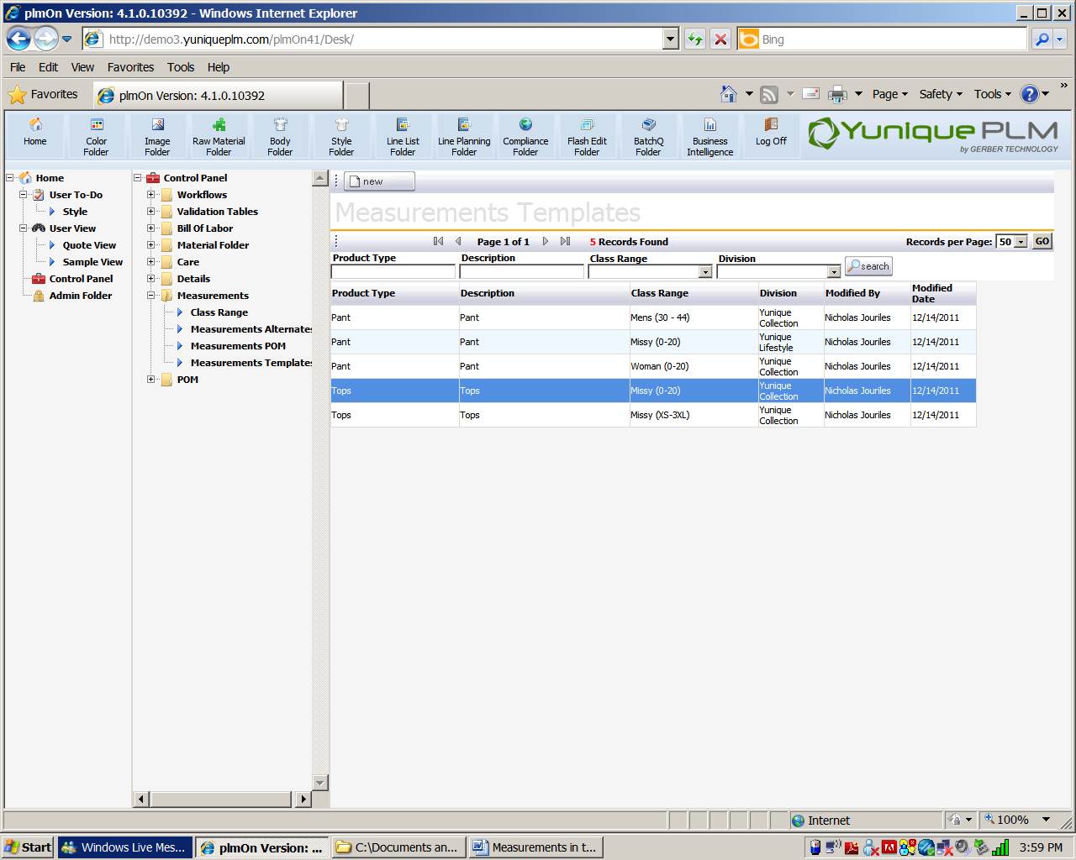

In the template, we can add the appropriate size ranges with their corresponding points of measure.

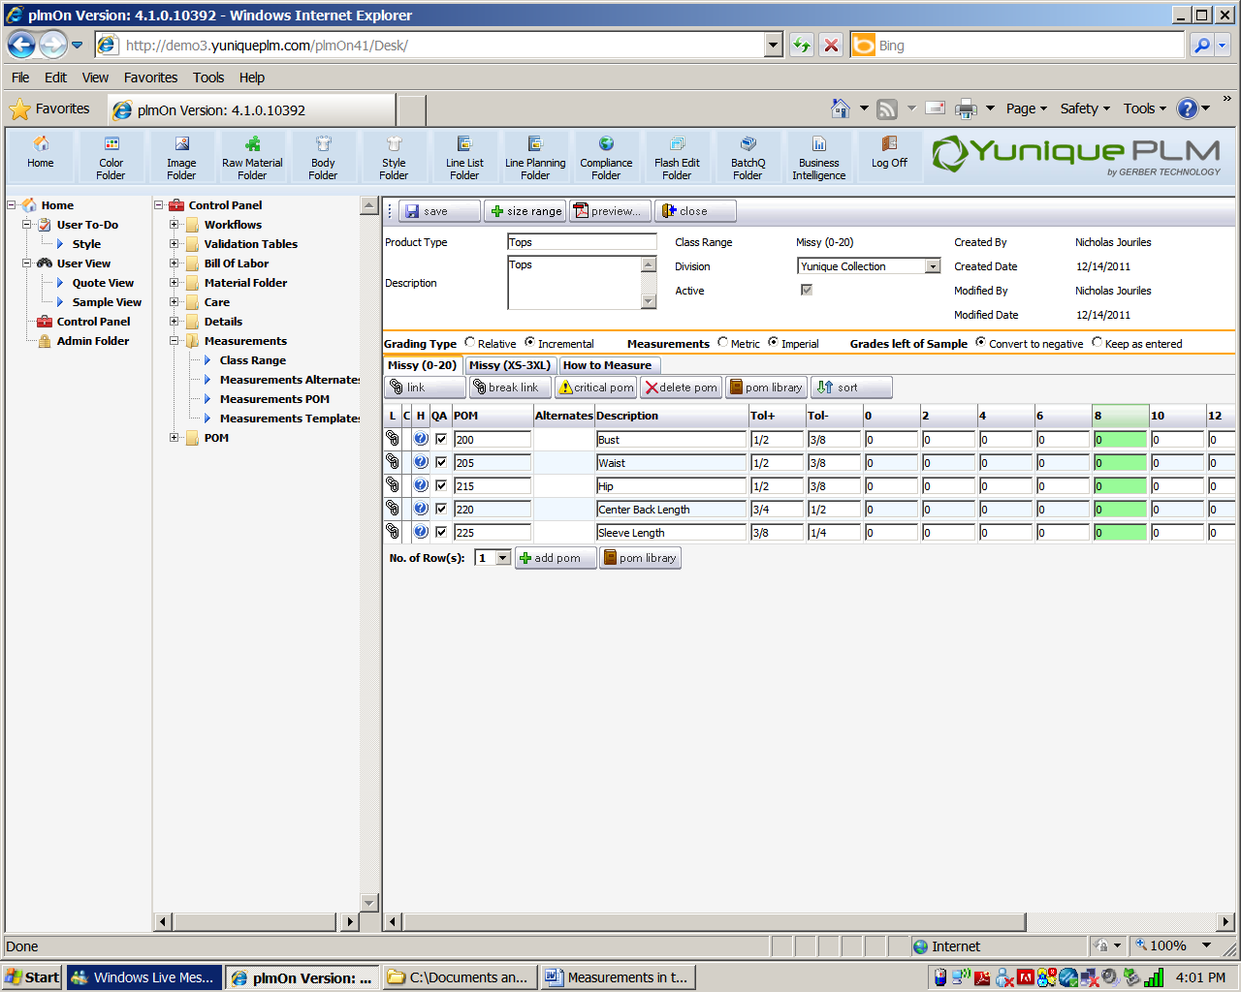

To add a size ranges to a size class, click on the **Size Range** button. 

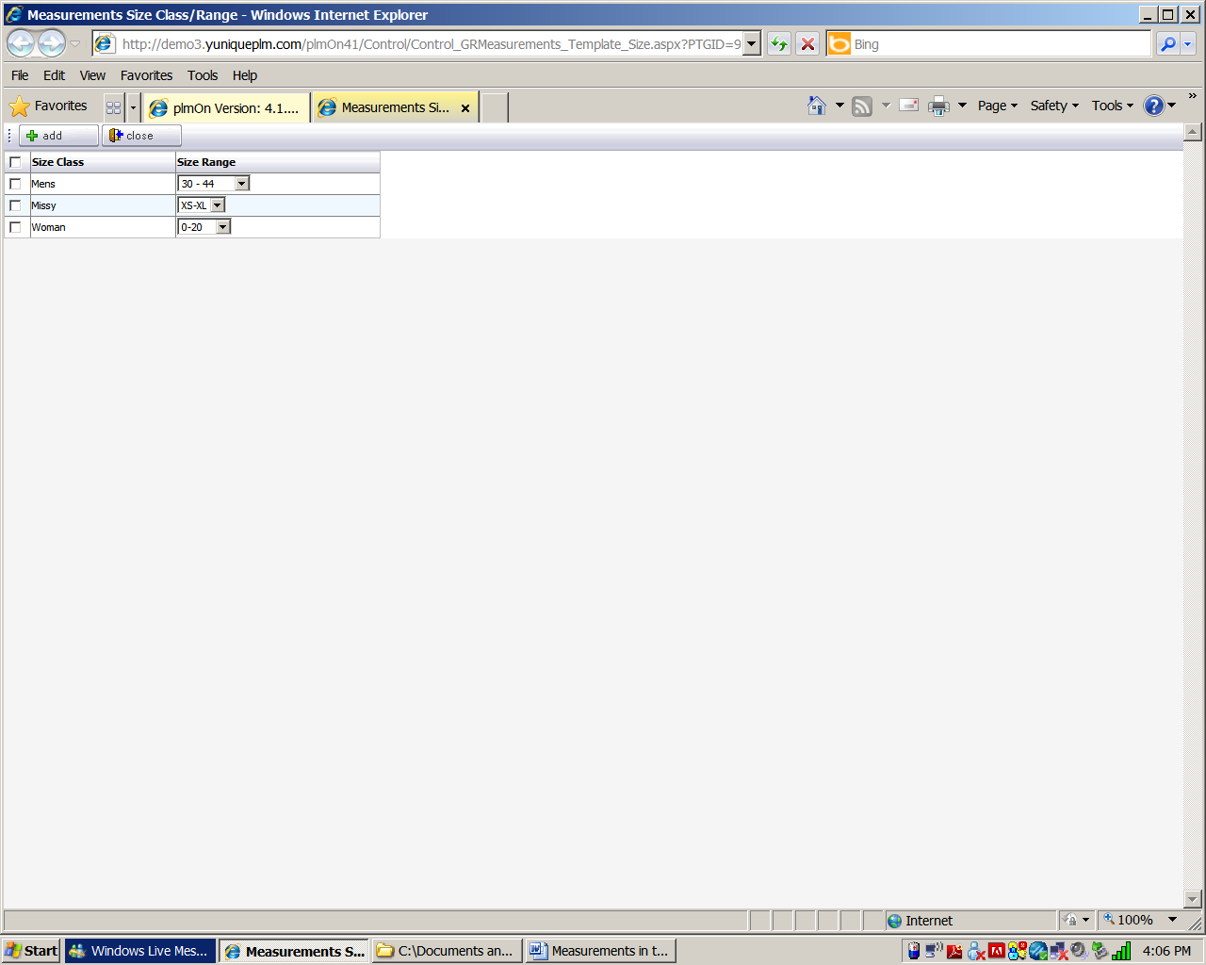

Select a size class/size range from the selection that appears. Click the **Add** button.

**\*NOTE:** If points of measure have been added to other size class/size ranges, those same points of measure will appear (if the link button appears) for the new selection just made.

To add Points of Measure to the templates, click on the **Add POM** or **POM Library** button(s).

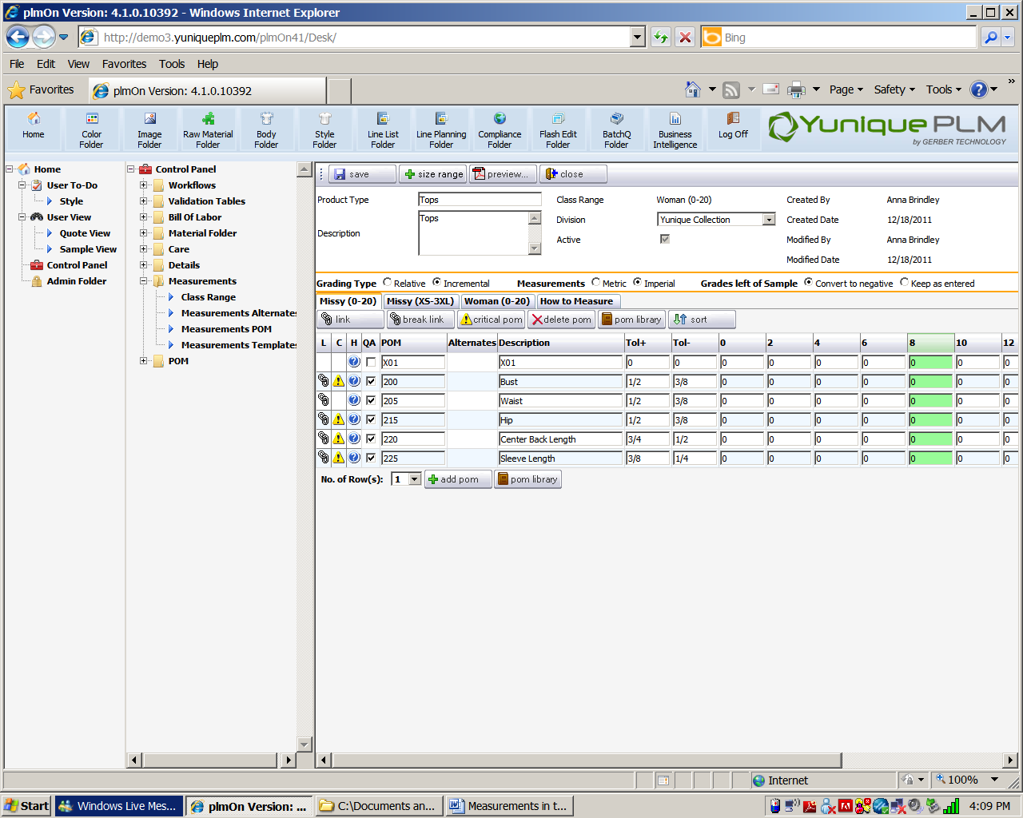

There are several icons in columns that are to the left of the POM (point of measure) records. Here are they are with their descriptions:

 **L** = **Linked.** Point of measures come in to the template linked to the POM library by default. To be linked means that if the record is changed, the information will be updated everywhere the linked item occurs

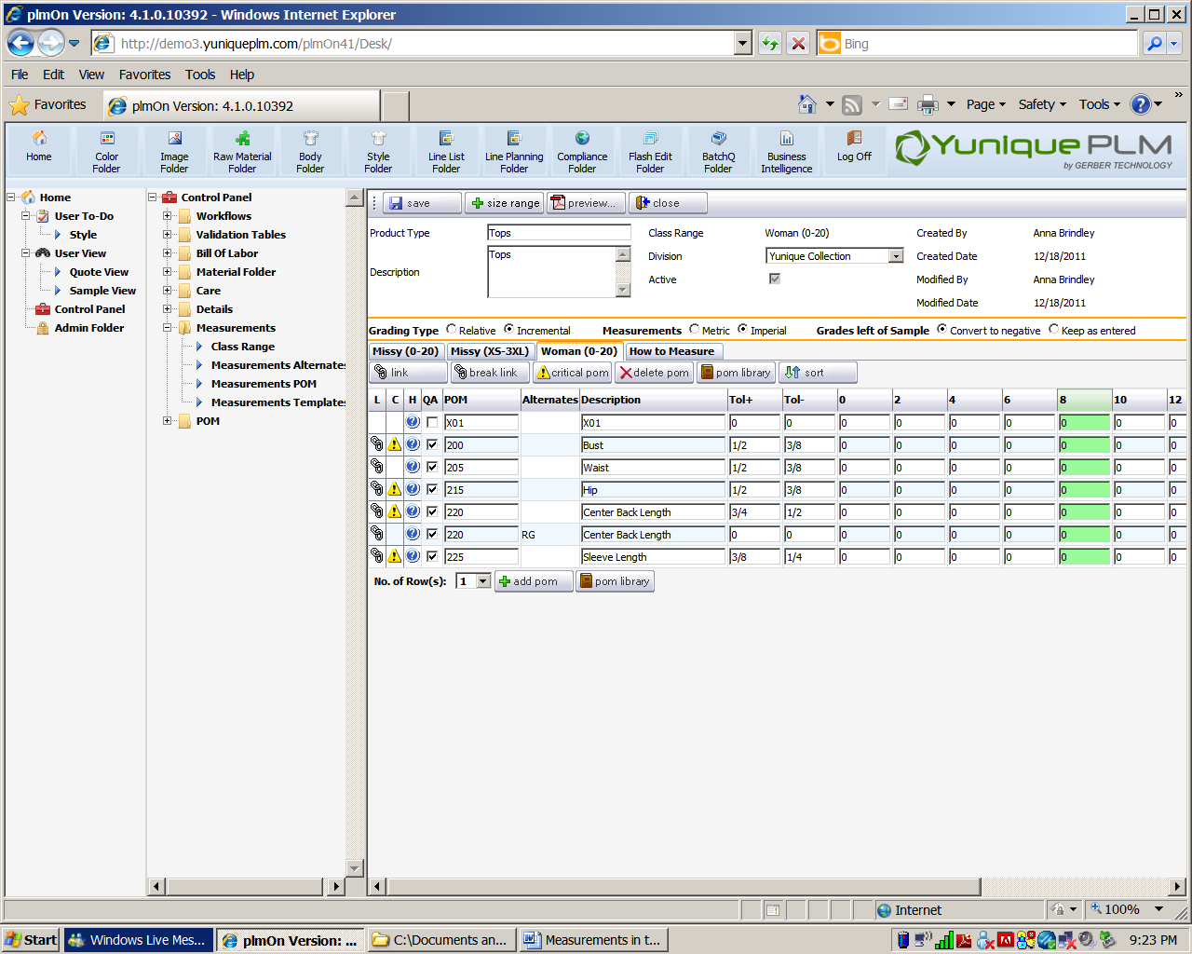 **C=Critical.** This icon indicates that the point of measure is critical in the development process of this style.

 **H=How to Measure.** Clicking on this icon will also allow one to view the How to Measure information.

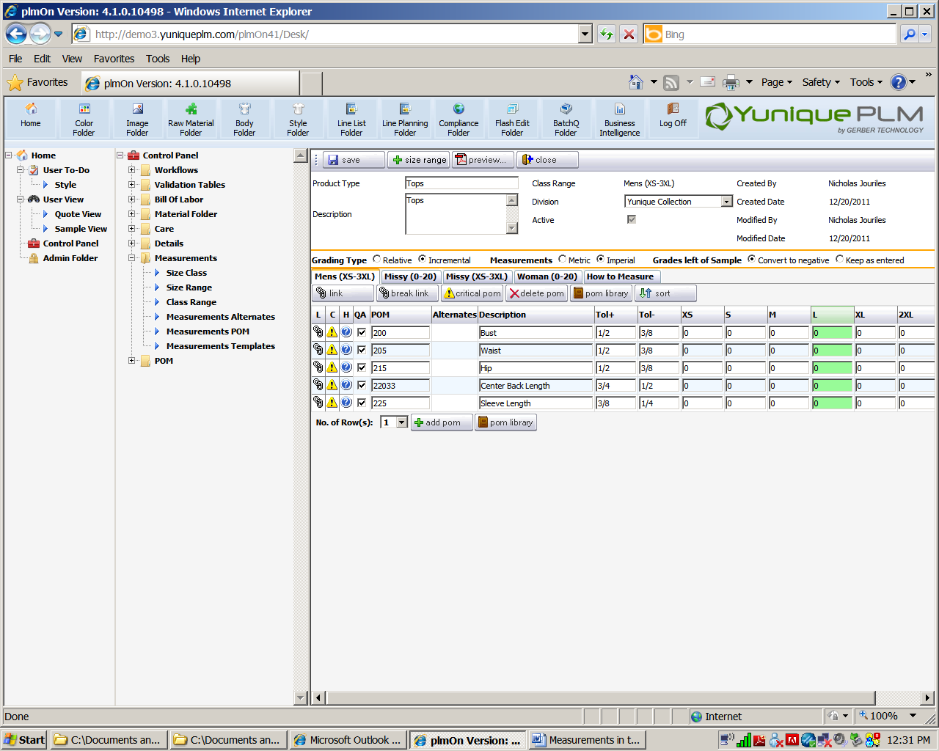 **QA** = **Quality Assurance.** Acheck mark indicates that this POM will show on Quality Assurance Sample Request. Left unchecked, the POM will not show on the Quality Assurance Sample Request.

 Click on the **Link** button to edit linked library.

 Click on the **Break Link** button to break the link of the POM from the library.

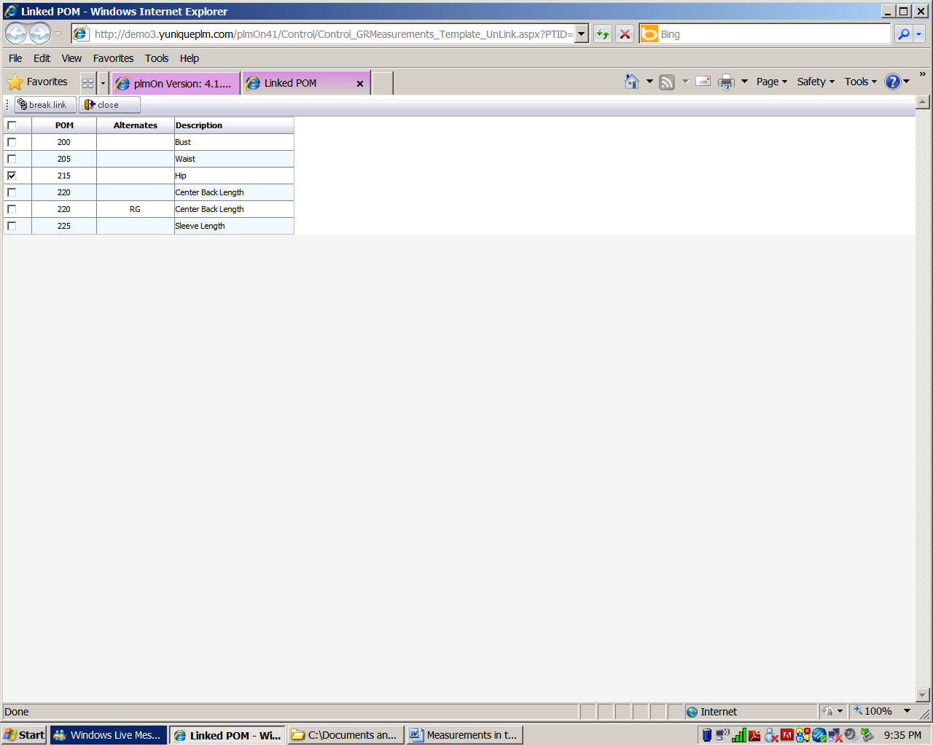

Check the Point of Measure (POM) to break the link and click the **Break Link** button or click **close** to discard changes.

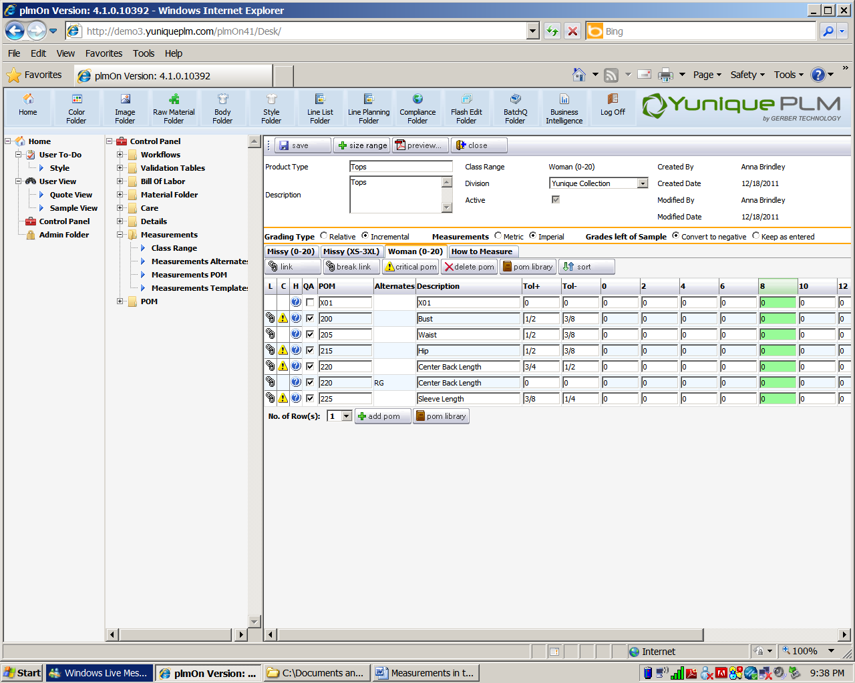 Click on the **Critical POM** to assign critical pom status to a point of measure.

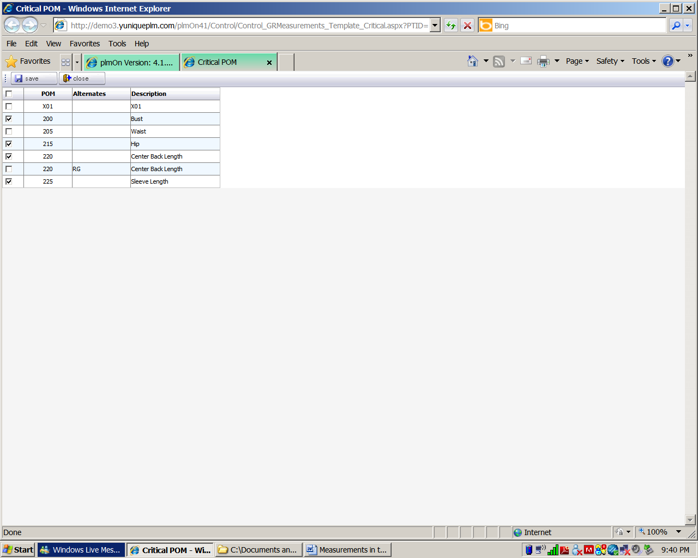

Click on the POM on the far left side to select it and click the **Save** button or click **Close** to discard changes.

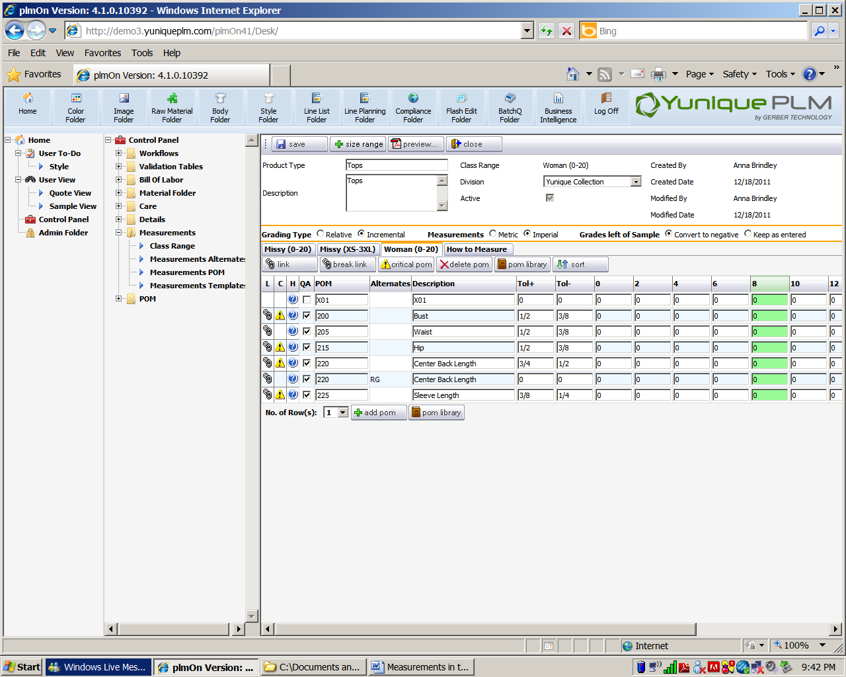 Click on **Delete POM** to delete a selected point of measure.

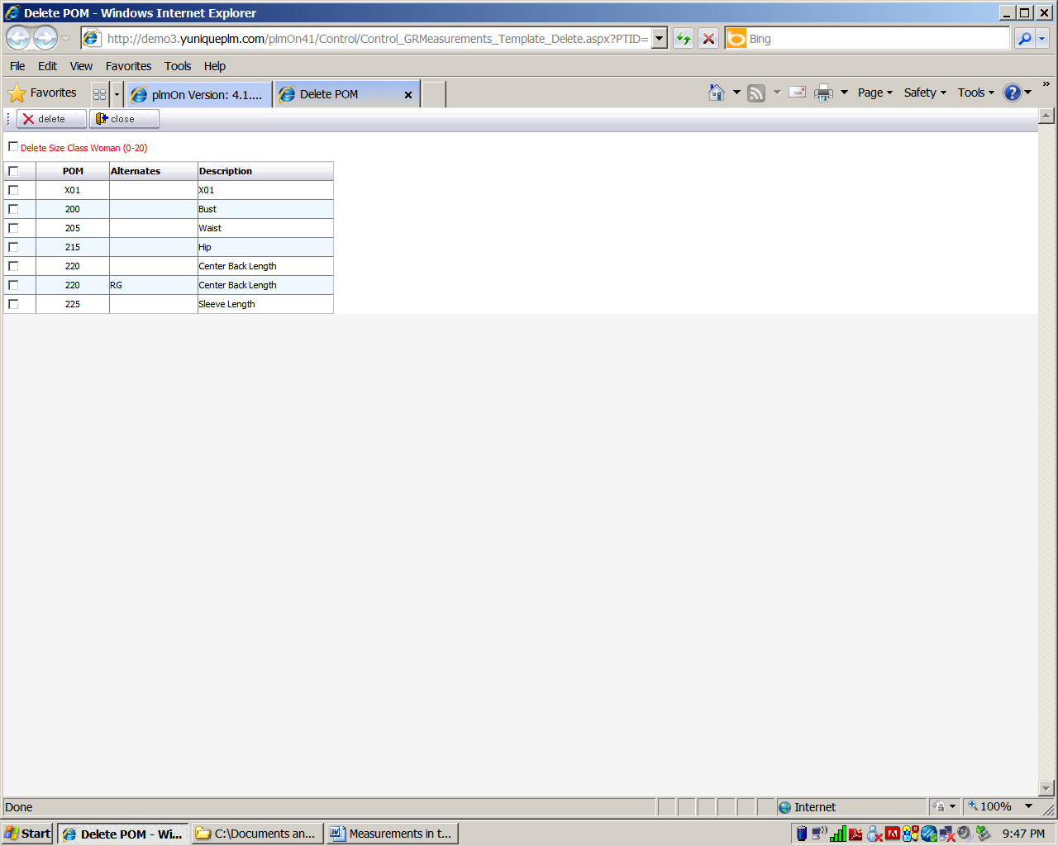

Select the POM to be deleted and click the delete button.

**\*NOTE:** in red is the option to Delete Size Class. Place a check mark in this box if the entire template is to be deleted.

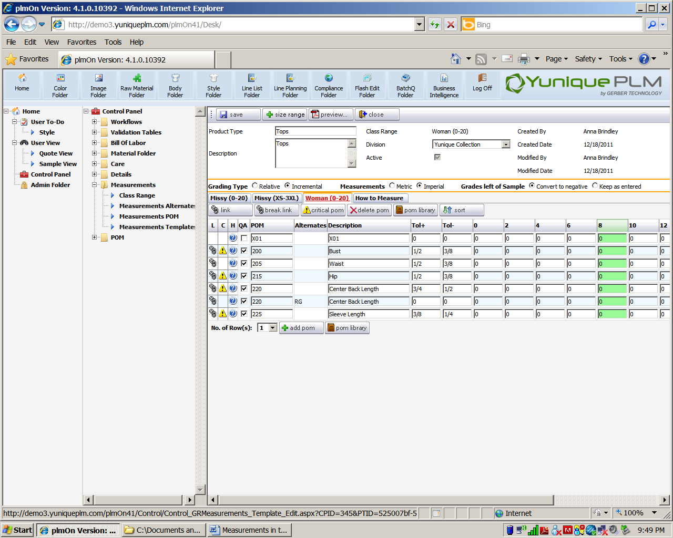 Click on the **POM Library** button to add points of measure to the templates.

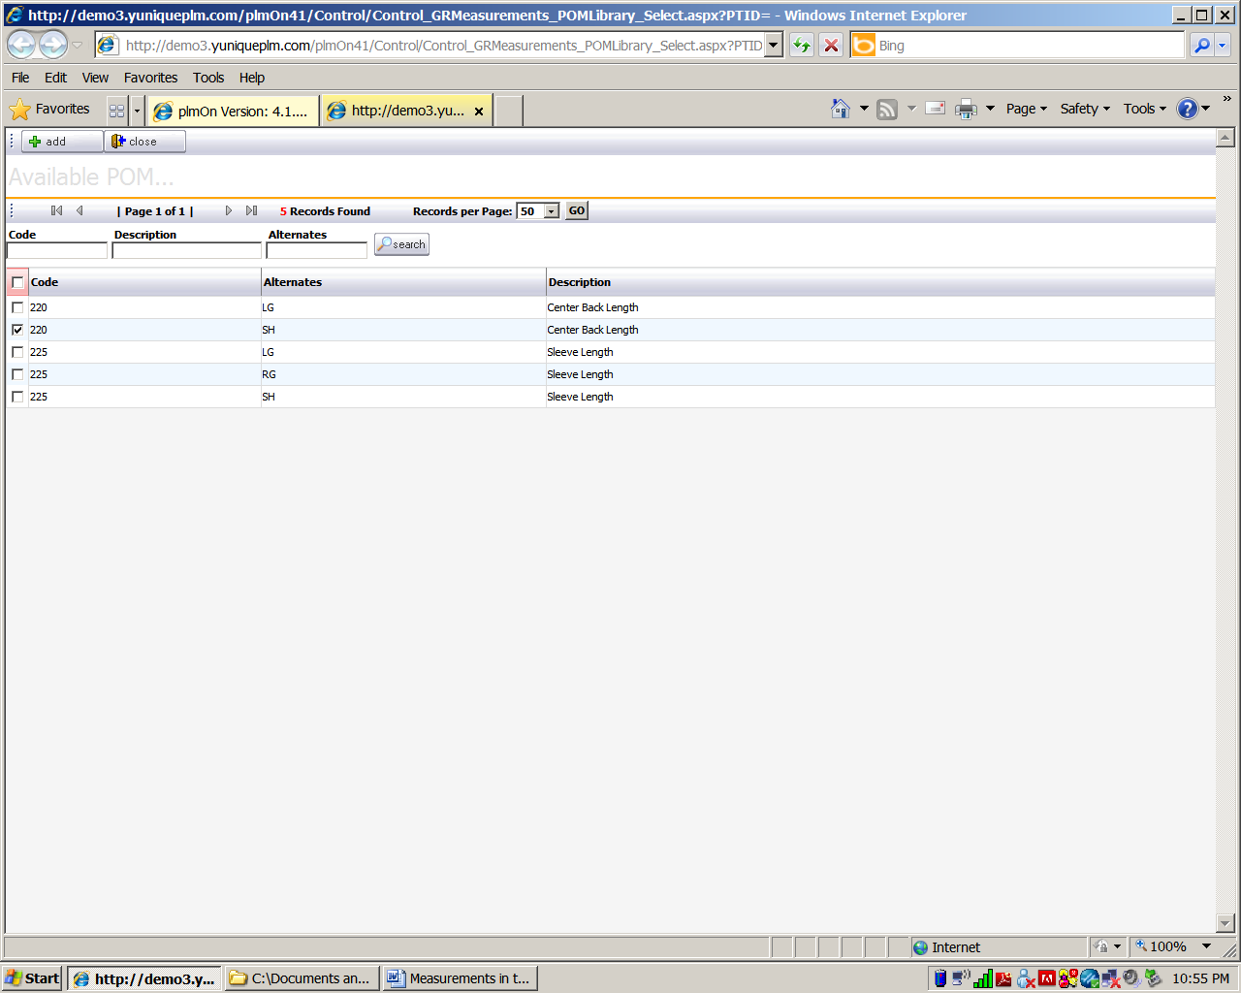

Select one or more points of measure and click the **Add** button. Click **Close** to discard changes.

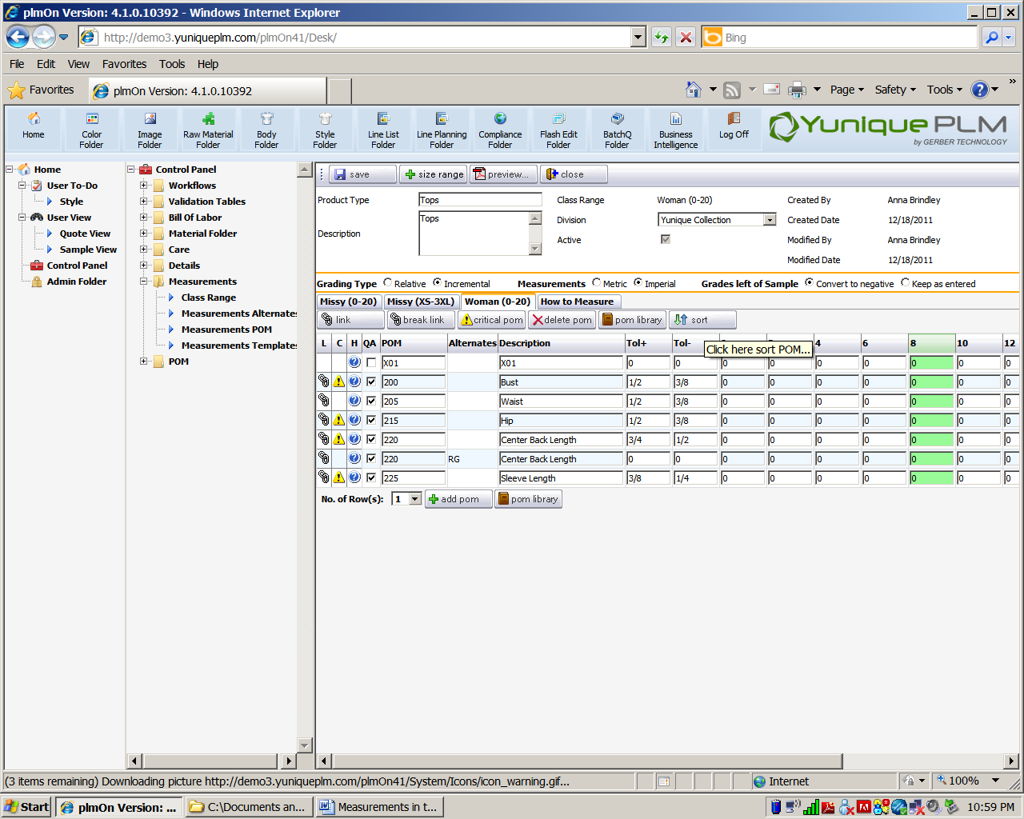 Click the **Sort** button to re-sort the points of measure. Points of measure will default to sorting by the given code.

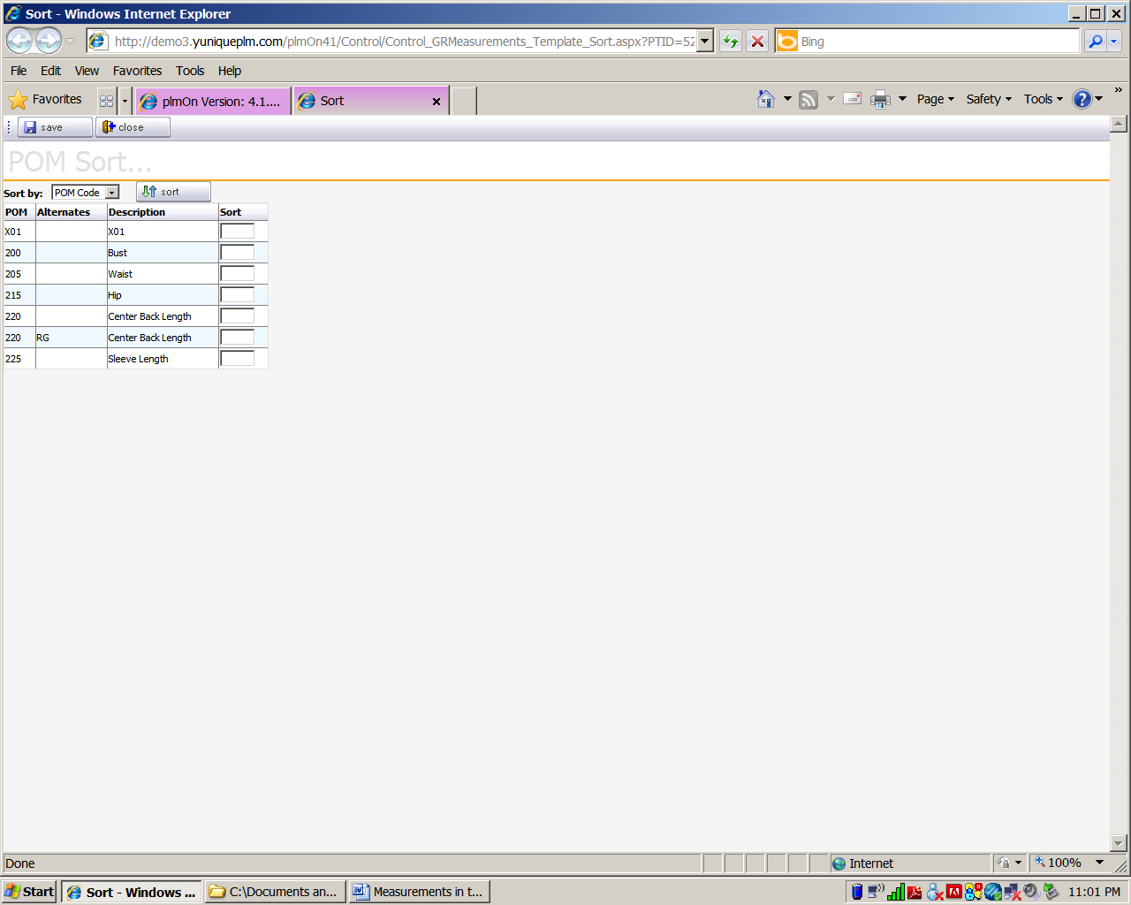

Place the numbers in the sort column for the new sort order. Click the **Save** button. Click **Close** to discard changes.

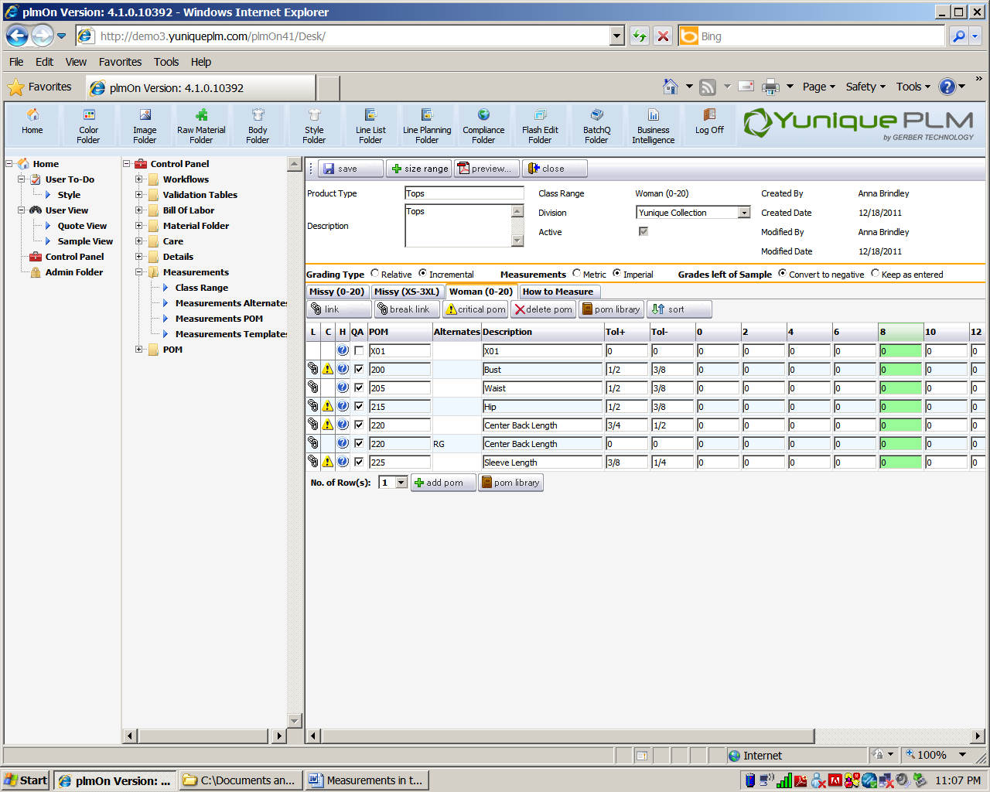

At the top of page, click **Save** to store all changes.

Click the **Size Range** to add a size range to the measurement templates.

Click the **Preview** button to see print out options.

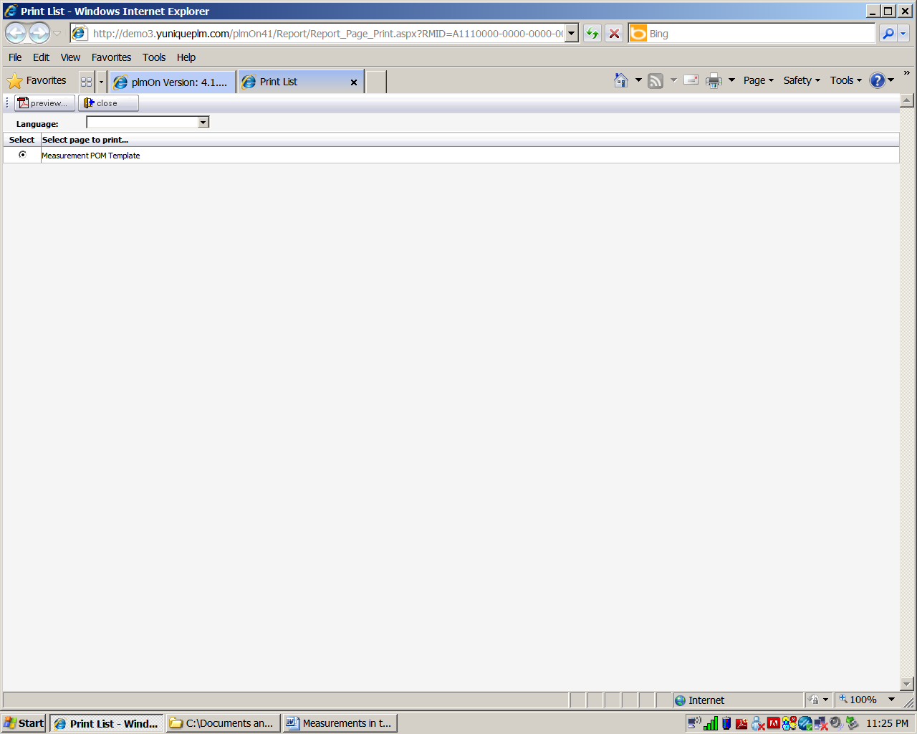

Click the **Preview** button in this screen to generate the .pdf of the page.

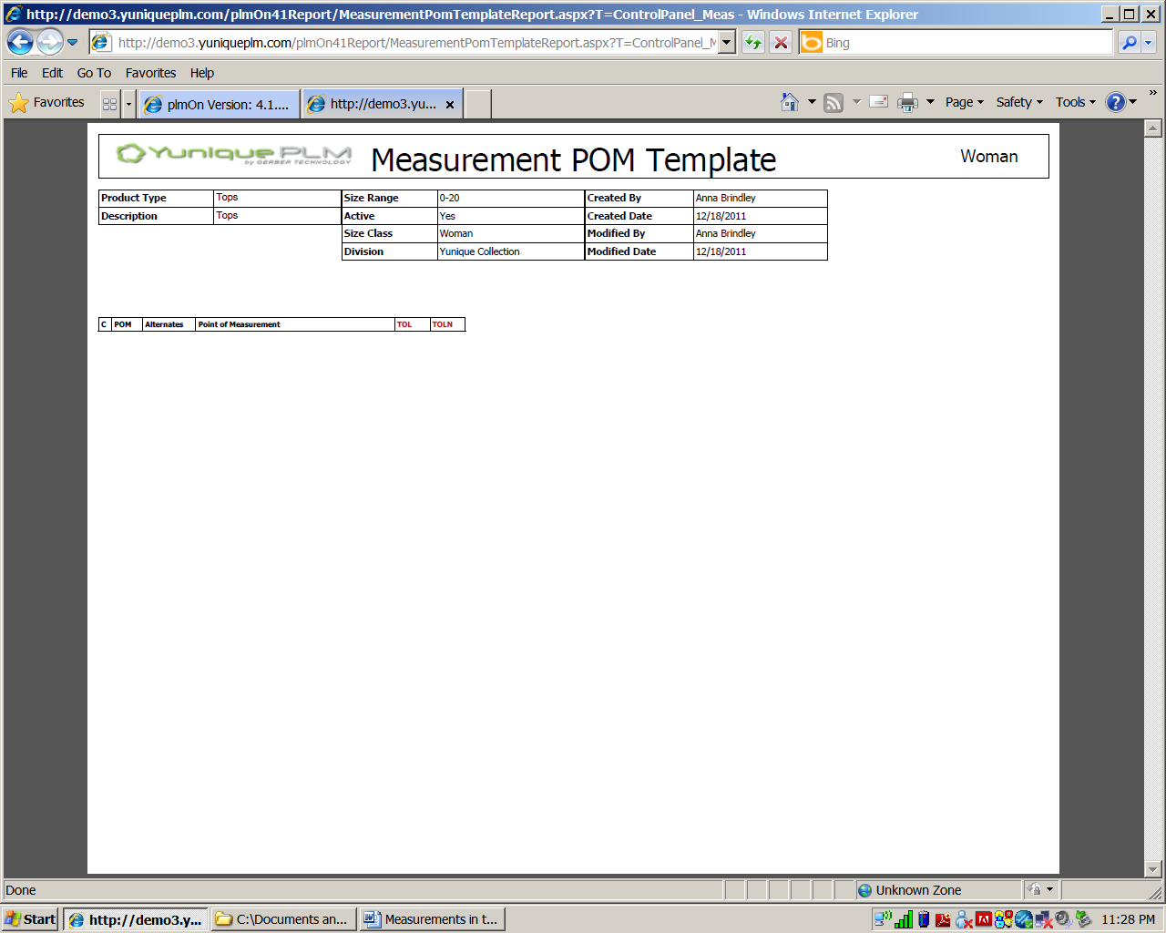

Click the **Cose** button to close.

**\*NOTE:** To save time use F function keys to enter fractions in all areas where measurement increments can be entered.

F1 = 1/8

F2 = 1/4

F3 = 3/8

F4 = 1/2

F5 = 5/8

F6 = 3/4

F7 = 7/8

**Workflow Libraries**

The workflow libraries are where the templates and timelines are established for various development purposes in the YuniquePLM application. Probably the most critical workflow library is the Dev. Workflow library. In this library, workflow templates are established for the various types of style folders that will be created and the pages or “bubbles” within these folders. The workflow libraries in the Control Panel are as follows:

* Dev. Workflow – Establishes the page bubbles for every style folder
* Sample Workflow – Establishes the milestone activities for sewn product samples.
* Material Development Workflow – Establishes the milestone activities for raw material development and samples.
* Body Workflow – Establishes the page bubbles for a body folder that can be used as a template silhouette.

The process of creating a new workflow type and adding milestone action items is the same for each of the workflow libraries. To create a new workflow type, click on the library name on the left side of the control panel window and then click on the New button across the top of the window.

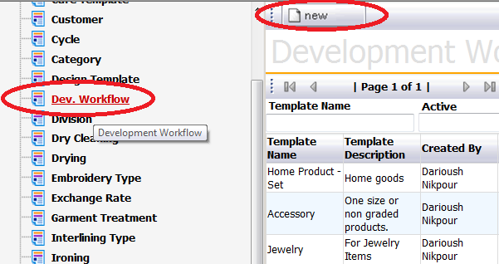

Enter a name and description for the new workflow template, and select “yes” from the Active field drop down list. Then click the Save button at the top of the window to store the record.

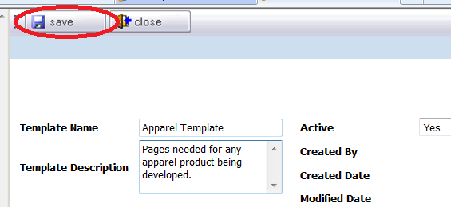

Once the record has been stored in the data base, action items can be selected for the workflow template by clicking on the Add button across the top of the screen.



A list of available action items and/or page ”bubbles” will be presented in the column on the left. The desired action item(s) can be highlighted by clicking directly on the title, and then moved over to the “Selected” list by using the green control arrows in the center of the window. Once listed in the Selected list, the action items can be arranged in the proper order by using the sort arrows on the far right. The first action item to occur in the workflow should appear at the top of the list, and flow in order going down. Once the list is complete and ordered correctly, click on the Save button across the top of the screen to store the new workflow template.

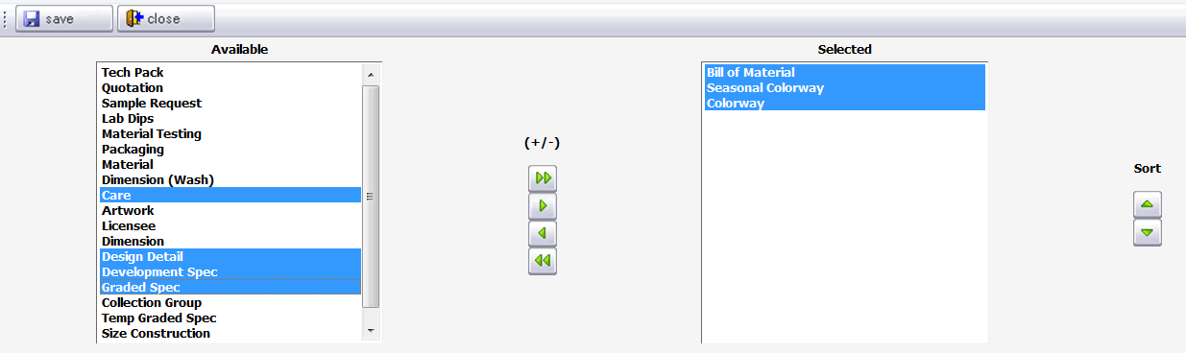

For each of the selected action items on the workflow template, a default responsible party can be assigned. The expected number of days for completion of each action item can be established along with the number of days for which an alert should be sent to the responsible party. This information can be changed if necessary, when the template is used for an actual style.

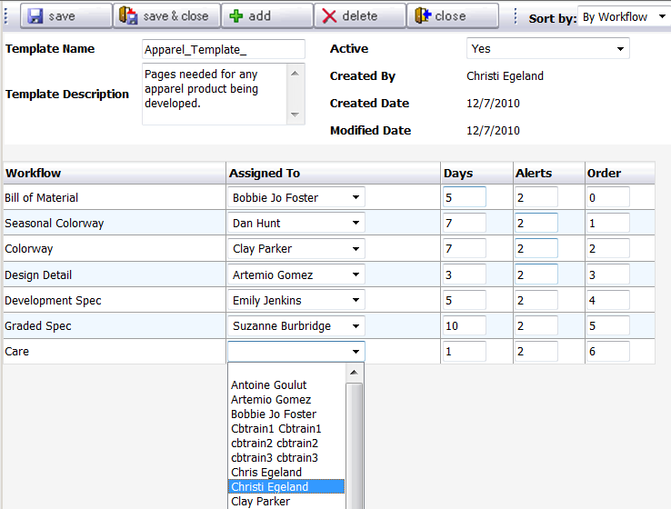

Once all known information has been entered, click on the Save and Close button to return to the Control Panel window.



To delete a workflow template, simply click on the Delete button across the top of the window.



A dialog will be presented to verify that the workflow should be deleted. Click OK to complete the process and return to the control panel.

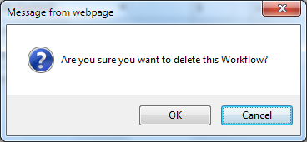

**Material Type Libraries**

The material type libraries are used to house data that will help to classify various raw material items stored in the Material Folder. The libraries include the following:

* Artwork
* Embroidery Type
* Interlining Type
* Knit Type
* Label Type
* Lining Type
* Material Treatment
* Packaging Type
* Stitch Type
* Tread Type
* Trimming Type
* Woven Type
* Yarn Type
* Zipper Type

To add data to a Material Type library, click on the library name from the left side of the Control Panel and then click on the New button across the top of the window.

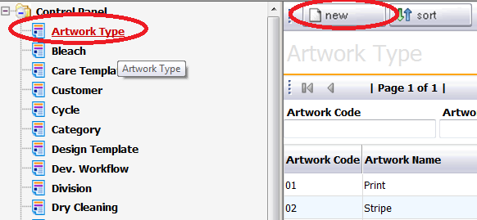

Populate all of the fields and click the Add button across the top of the screen to store the record.

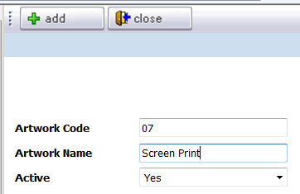

To remove a record from the library, click on the desired record name to open. Once the record is opened click on the Delete button across the top of the screen.



**Care Libraries**

The care libraries will populate the dropdown fields of the Care page “bubble” of a style folder. The Care Libraries include the following:

* Bleach
* Cycle
* Dry Cleaning
* Drying
* Ironing
* Washing

To add data to a care library, highlight a library from the left side of the control panel and then click the New button across the top of the window.

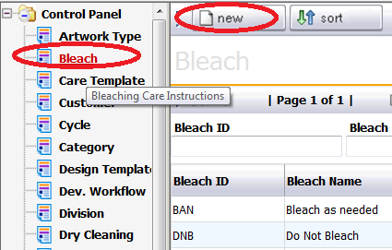

Populate all fields with appropriate data and click the Add button across the top of the screen to store the new record.

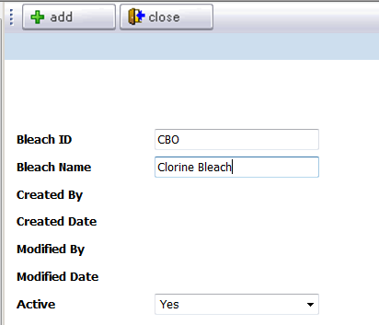

To remove a record from the library, click on the desired record name to open. Once the record is opened click on the Delete button across the top of the screen.



**Care Template**

Once each of the care libraries contains all necessary data, specific groupings of data from each of these libraries can be gathered together to create templates. To create a new Care Template, highlight the menu on the left side of the Control Panel and click the New button across the top of the screen.

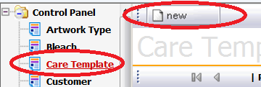

Populate all fields with appropriate data and click the Save button across the top of the screen to store the new record.

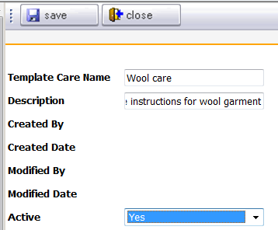

**Details**

Process Details

The process details library is where approved or standardized instructional information for a variety of purposes can be stored in a logical format. Everything from sewing instructions, to packaging and labeling instructions can be stored in this library. This allows for information that is regularly used to correctly develop products to be approved and saved and accessed easily when needed.

To begin entering information in the process details library, highlight the node on the left side of the explorer window. To the right the different process details folders or “class levels” will be displayed.

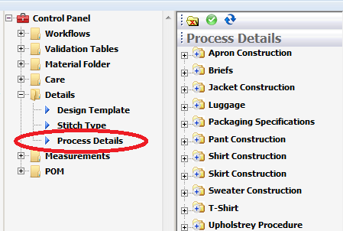

To add a new process detail class folder, begin typing the folder name in the field provided in the far right window and then click the **Save as New** button across the top of the screen.

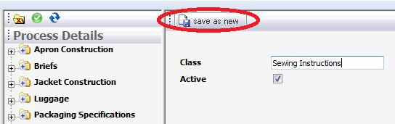

The newly added class folder will populate in the folder list on the left in alpha numeric order. Click on the **Add Subclass** button across the upper right of the screen to add more specific folders related to the class level folder.

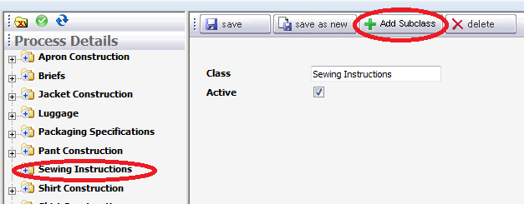

Enter the name of the new subclass level in the field provided and then click the **Save as New** button across the top of the screen.

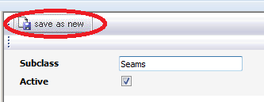

Once the record has been saved new feature items can be added. A feature is where the specific instructions are given. An example would be sewing side seams or attaching a collar. To add a new feature, click on the **New Feature** button on the right side of the screen.

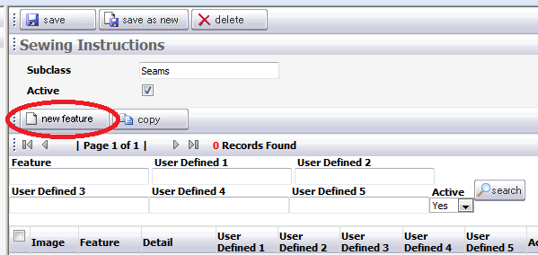

Enter the feature name, and then in the details field type the instructions appropriate to complete the feature. Additional information can be entered in the five user defined fields provided.

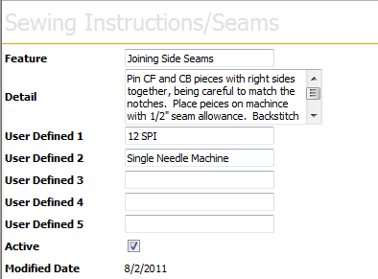

An image can be added to help illustrate the feature instruction. To add and image, click on the **Browse** button on the far right of the screen. Locate the appropriate image from a network location. The image file name and location will populate in the Image File field.

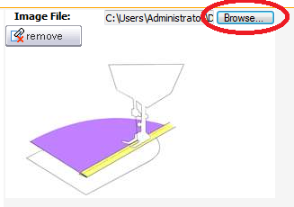

Once all information associated to the new feature is added, click on the **Add** button in the upper right corner.



Repeat this process for as many Class levels, Subclass levels, and Feature instructions needed.

**\*NOTE:** The user defined fields can be translated to more meaningful labels in the Admin Folder in the Languages area. Please reference the Administration Folder document to learn how to do this.